A simple java application docker image build with maven

Step 1: Create a docker file with “touch Dockerfile”

Add the following contents

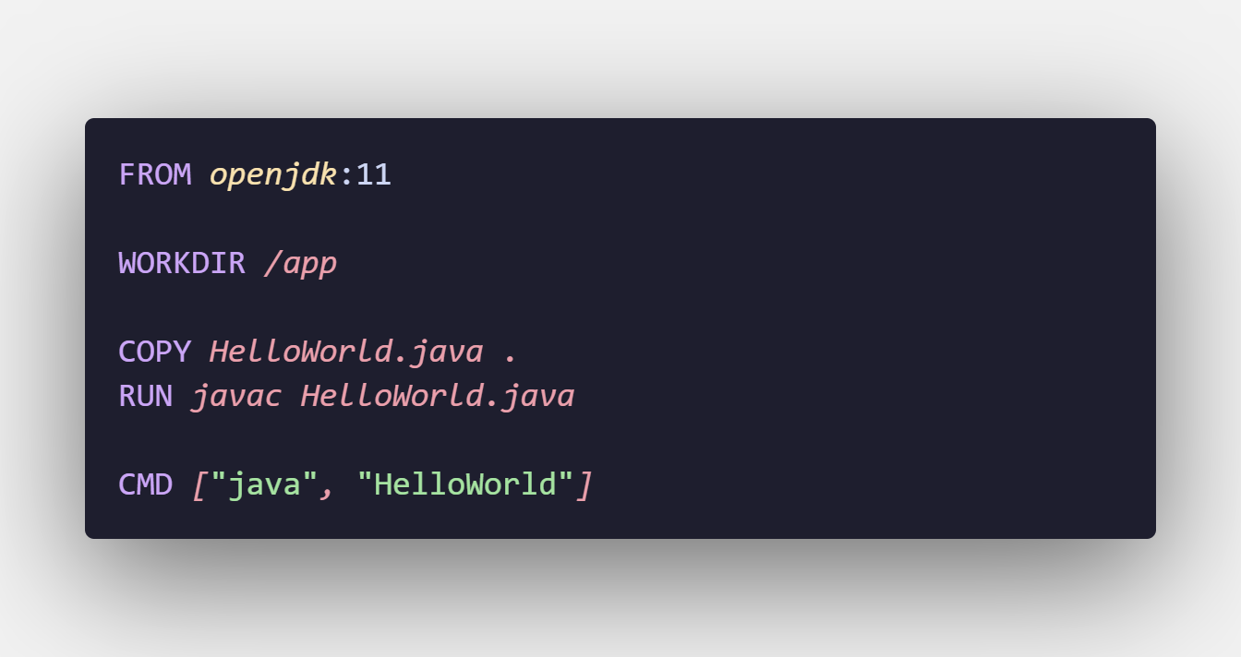

Setp2: built the image

“docker build –t hello-world-app .”

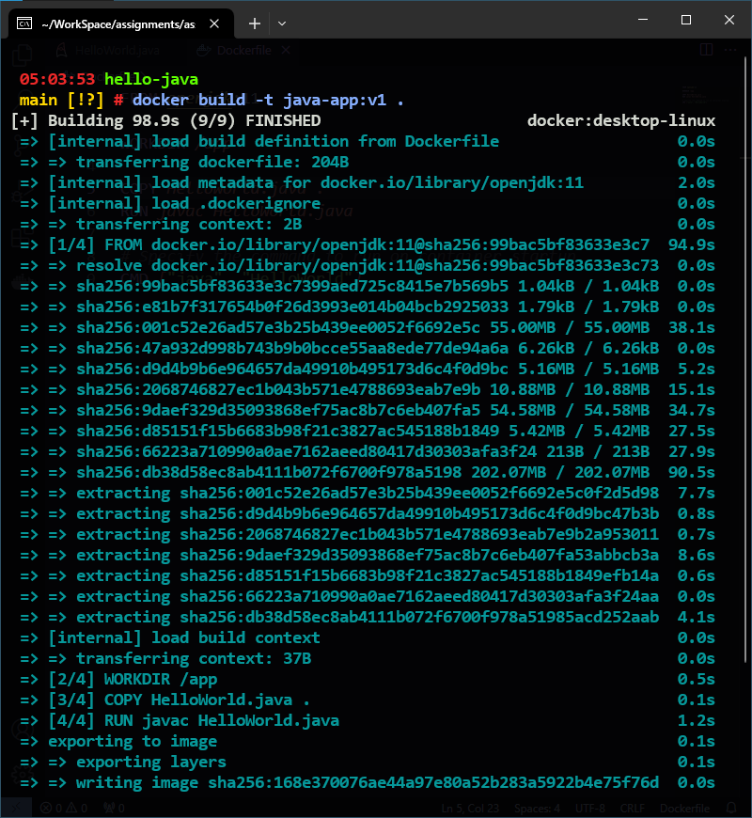

Setp3: run the image in container

“docker run –rm java-app:v1”

